**Please submit the news item (two pages max.) and all related files (photos, documents, etc.) to the e-mail address** [**JRC-COE-DELIVERABLES@ec.europa.eu**](mailto:JRC-COE-DELIVERABLES@ec.europa.eu)

[Please see Instructions on second page, point 4, for an example of a complete workflow for drafting and submitting a news item.]

**News article header**

**[15 words max – the shorter, the better!** Please see Instructions on second page, point 1, for detailed guidance and examples.]

News article sub-head

**[25 words max – the shorter, the better!** Please see Instructions on second page, point 2, for detailed guidance and examples.]

Photo

**[**Please see Instructions on second page, point 3, for details.]

**News article – intro, body and closing:**

**Intro – first paragraph: Context on C/B/R/N risk(s) addressed**

The news article should start by providing some key context on the C/B/R/N risk(s) addressed, so that non-expert readers can get a clear sense of the significance of the risk(s) and the importance of the action that has been taken (described in the body of the article) to mitigate the risk(s). Ideally, the intro should be only one-paragraph, providing:

* A brief description of the **benefits** (for society, the environment, the economy, etc.) of the C/B/R/N material or technology in question, offering examples of real-life applications as appropriate
* A brief description of the specific **risks** (for society, the environment, the economy, etc.) posed by the C/B/R/N material or technology
* The **importance of advancing relevant measures** (policies, technologies, knowledge, etc.) to help mitigate these risks

**Body – main paragraphs: CoE-supported action to mitigate the risk(s)**

The body of the article should focus on the CoE-supported action taken to mitigate the risk(s) introduced above. This action should be a concrete achievement, ideally one led or co-led by a Partner Country or Region, that can reasonably be expected to reduce the likelihood or impact of the risk(s) in question. Concrete actions of this kind could include new legislation/regulations/SOPs adopted/implemented by a country, the set-up of a regional system to share information/alerts, the publication of manuals/guidebooks/research articles, field exercises, awareness-raising campaigns, and trainings that have contributed to a change in behaviour, etc. Ideally, the body of the text should be between 2-5 paragraphs, detailing:

* Scope of the **CoE-supported action** in relation to the risk
* Who **led and/or participated?** Emphasis should be placed on the role played by the Partner Country or Region in the action’s development and implementation
* What was the added value? How did it benefit the Partner Country/ies or Region/s?
* What are the **next steps and/or opportunities for sustainability**? How can the achievement be sustained, built upon, replicated, or expanded in the future?
* Any **further relevant information** (link with other outputs, quotes/testimonials, etc.)

**Closing – last paragraphs: CoE Project background information**

The closing should provide background information on the CoE Project under which the particular action was delivered. Ideally, this should be no more than 3 to 4 paragraphs, providing:

* A clear **link between the action/achievement and the CoE Initiative/CoE Project**
* Background on the **CoE Project’s scope/goals** and, if well-established, a few highlights of **main achievements or progress made** during its implementation
* Indicate the **Project’s timespan, implementers and participating countries**
* A final **‘to know more’ link**, inviting readers to visit the Project page available on the CoE public website or the Project’s standalone official website

**Instructions**

1. The **news article header** should highlight the particular achievement realised. It should, to the extent possible, be framed from the Region’s or Partner Country/ies’ point of view, and no reference to the CoE or a specific Project is needed. It should be drafted in the present tense and call readers’ attention to the story in no more than 15 words – **the shorter, the better!**

Please see examples below:

* [*Prospective study shows effectiveness in the control of leishmaniasis vectors*](https://cbrn-risk-mitigation.network.europa.eu/news-0/prospective-study-shows-effectiveness-control-leishmaniasis-vectors-2022-09-22_en)
* [*Singapore advances responsible use of life sciences with new Biorisk Code of Conduct*](https://cbrn-risk-mitigation.network.europa.eu/news-0/singapore-advances-responsible-use-life-sciences-new-biorisk-code-conduct-2022-09-05_en)
* [*Advancing guidance in the investigation and prosecution of chemical and biological crimes*](https://cbrn-risk-mitigation.network.europa.eu/news-0/advancing-guidance-investigation-and-prosecution-chemical-and-biological-crimes-2022-07-15_en)
* [*Contributing to the mitigation of COVID-19 in the African Atlantic Façade region*](https://cbrn-risk-mitigation.network.europa.eu/news-0/contributing-mitigation-covid-19-african-atlantic-facade-region-2022-06-01_en)

1. The **news article sub-head** should concisely expand on the achievement presented in the header. This sentence should offer a brief but insightful look at key facts to awaken readers’ interest in the full piece. It should be drafted in the present (or, in some instances, future) tense and should not exceed 25 words.

Please see examples below:

* [*First-of-its-kind study suggests insecticide thermal fogging can play important role in reducing transmission of neglected vector-borne disease*](https://cbrn-risk-mitigation.network.europa.eu/news-0/prospective-study-shows-effectiveness-control-leishmaniasis-vectors-2022-09-22_en)
* [*The document furthers Singapore’s commitment to prevent the potential misuse of the life sciences by promoting a culture of responsibility amongst life science professionals and industry*](https://cbrn-risk-mitigation.network.europa.eu/news-0/singapore-advances-responsible-use-life-sciences-new-biorisk-code-conduct-2022-09-05_en)
* [*Newly released guidebook will provide police, prosecutors and investigative agencies with guidance for the prosecution of incidents involving chemical or biological agents*](https://cbrn-risk-mitigation.network.europa.eu/news-0/advancing-guidance-investigation-and-prosecution-chemical-and-biological-crimes-2022-07-15_en)

1. A **compelling/impactful photo** can be embedded in the news article and shared as a separate high-quality image file when submitting the piece via email. Please note that an alternative Creative Commons photo selected by the EU CBRN CoE Content Manager might be used instead in the final article.

Before sending any photo make sure that:

Intellectual property is protected and the rights to use the image can be transferred to the EC for communication purposes

Personal data are protected, in case of images with recognisable persons, you need to collect a formal consent which is specifying that the EC can use it for communication purposes. Models for consent in all languages are available on <https://audiovisual.ec.europa.eu/en/album/M-002505>, The model in EN is hereby annexed.

1. The specific **workflow** for drafting and submitting news items should be agreed with the Regional Secretariat. To the extent possible, submissions should be done in partnership/coordination with the Partner Country, national/regional entity or local expert that led/supported the development/implementation of the activity featured in the article. One possible workflow is detailed below:
   * Project Team Leader, in coordination with co-author(s) representing concerned national/regional entity/ies, prepares first draft
   * Project Team Leader emails draft to Regional Secretariat (Team Assistant and/or Regional Coordinator) for preliminary review and revision
   * Regional Secretariat submits advanced draft to JRC ([JRC-COE-DELIVERABLES@ec.europa.eu](mailto:JRC-COE-DELIVERABLES@ec.europa.eu)) for final review, formatting, and proofreading
   * JRC publishes final news items on CoE public website

**Singapore advances responsible use of life sciences with new Biorisk Code of Conduct**

*The document furthers Singapore’s commitment to prevent the potential misuse of the life sciences by promoting a culture of responsibility amongst life science professionals and industry*

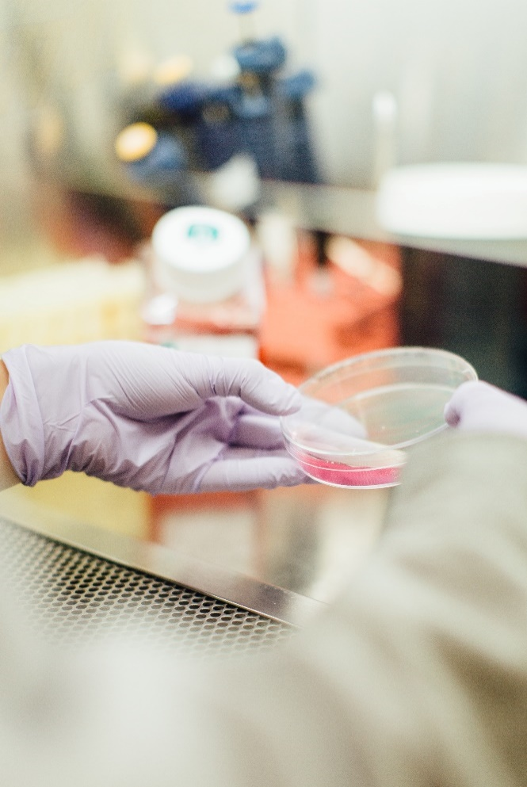***EXAMPLE***

***EXAMPLE***

Advances in the life sciences and biotechnology are a source of many benefits to human health, the environment and the global economy. From new pharmaceuticals and medical devices to biotechnology-based food, to name but a few applications, the life sciences are advancing at an increasing pace offering new opportunities for the planet. However, the same advances can also pose threats to public health and safety as the result of accidents or deliberate misuse. Managing these risks requires that life science professionals and industry demonstrate foresight and responsibility to ensure secure and sustainable scientific progress.

To this end, the Biorisk Association of Singapore (BAS) has launched Singapore’s *Biorisk Code of Conduct for Life Sciences Industry and Professionals*, an important document that seeks to prevent the potential misuse of the life sciences by promoting a culture of responsibility amongst those involved in activities with biohazardous materials.

In development for three years, the Code was prepared by the BAS with support from Singapore’s Ministry of Health. Supporting these efforts, legal experts with EU CBRN CoE Project 81 [‘BIOSEC - Enhanced Biosecurity in South-East Asia’](https://cbrn-risk-mitigation.network.europa.eu/projects-pool-page-use-list-page-instead/project-081_en) provided comments on the document’s drafts and presented on dual-use research governance during the Code’s [online launch event](https://biorisk.sg/home/2022/05/25/responsible-life-sciences-webinar-launch-of-coc/).

Singapore’s *Biorisk Code of Conduct for Life Sciences Industry and Professionals* aims to ensure the promotion of best practices stemming from the Biological and Toxins Weapons Convention, UN Security Council Resolution 1540, the International Health Regulations and WHO biosecurity guidance, as well as compliance with relevant national acts and regulations. The document lays down appropriate principles of ethical standards, awareness raising, risk assessment and mitigation, oversight and accountability, and communications.

Scientists, research institutions, industry and funding agencies in Singapore will be encouraged to incorporate elements of the Code in their institutional and company practices, protocols, and guidelines.

**Supporting the enhancement of biosecurity in South East Asia**

The European Union supported the launch of Singapore’s *Biorisk Code of Conduct for Life Sciences Industry and Professionals* as part of its program to mitigate risks arising from chemical, biological, radiological and nuclear materials and agents in cooperation with its 63 Partners Countries.

EU CBRN CoE Project 81 [‘BIOSEC - Enhanced Biosecurity in South-East Asia’](https://cbrn-risk-mitigation.network.europa.eu/projects-pool-page-use-list-page-instead/project-081_en) is led by the implementer Sustainable Criminal Justice Solutions in cooperation with other European entities. The project aims at providing a set of tools for improving biosecurity management systems in South East Asia with a focus on capacity-building directed at highly communicable diseases with global catastrophic potential, including pandemics.

Launched in 2019, BIOSEC is active in Brunei Darussalam, Cambodia, Indonesia, Lao PDR, Malaysia, Myanmar, Philippines, Singapore, Thailand and Viet Nam.

*Singapore’s* Biorisk Code of Conduct for Life Sciences Industry and Professionals *can be accessed through the link below. To learn more about how the EU CBRN CoE is supporting the enhancement of biosecurity in South East Asia, please visit the* [*CoE Project 81 BIOSEC website*](https://www.cbrn-project81.com/)*.*