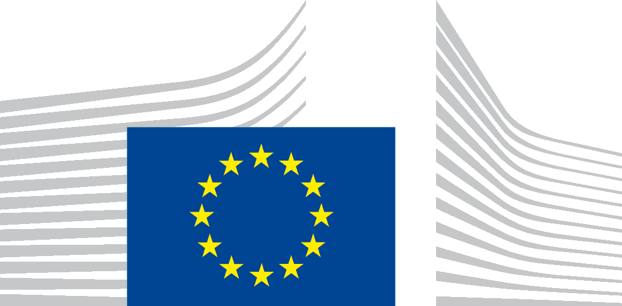 | EUROPEAN COMMISSION

PROTECTION OF YOUR PERSONAL DATA

Processing operation: title
Data Controller: European Commission, Service for Foreign Policy Instruments, FPI.01
Record reference: DPR-EC-1063

Table of Contents
- Introduction
- Why and how do we process your personal data?
- On what legal ground(s) do we process your personal data?
- Which personal data do we collect and further process?
- How long do we keep your personal data?
- How do we protect and safeguard your personal data?
- Who has access to your personal data and to whom is it disclosed?
- What are your rights and how can you exercise them?
- Contact information
- Where to find more detailed information?

1. Introduction
The European Commission is committed to protect your personal data and to respect your privacy. The Commission collects and further processes personal data pursuant to Regulation (EU) 2018/1725 of the European Parliament and of the Council on the protection of natural persons with regard to the processing of personal data by the Union institutions, bodies, offices and agencies and on the free movement of such data.
This privacy statement explains the reason for the processing of your personal data in the context of title, organised by the European Commission. It explains the way we collect, handle and ensure protection of all personal data provided, how that information is used and what rights you have in relation to your personal data. It also specifies the contact details of the responsible Data Controller with whom you may exercise your rights, the Data Protection Officer and the European Data Protection Supervisor.
The information in relation to the processing of personal data linked to the specific event, organised by the services of the European Commission, is presented below.

2. Why and how do we process your personal data?
Purpose of the processing operation: the European Commission collects and further processes your personal data to provide you with information about the specific meeting (before, during and after) and to process your application for participation in that meeting.
Your personal data will not be used for any automated decision-making including profiling.

Photographs of the speakers and panoramic photographs of participants and organisers will be taken and published in the context of the meeting on the European Union Chemical, Biological, Radiological and Nuclear Risk Mitigation web site, the European Commission website, the European External Action Service website, xxxx and other social media (ie. X, linkedIN), in the EU CBRN Newsletter and they will be used for reporting.
Participants that do not wish to be part of the above web-streaming and recording/publishing activities have the possibility to object to processing by sitting in back rows.

3. On what legal ground(s) do we process your personal data?
The processing operations on personal data, linked to the organisation, management, follow-up and promotion of the meeting (including photos, audio-visual recording) are necessary for the management and functioning of the Commission, as mandated by the Treaties (article 11 of the Treaty on European Union and article 15 of the Treaty on the Functioning of the European Union.
Consequently, those processing operations are lawful under Article 5(1)(a) of Regulation (EU) 2018/1725 (processing is necessary for the performance of a task carried out in the public interest or in the exercise of official authority vested in the Union institution or body).
The processing operations on personal data of the speakers for the meeting with whom a contract is concluded, are carried out in line with the contractual provisions. Consequently, that processing is necessary and lawful under Article 5(1)(c) of Regulation (EU) 2018/1725 (processing is necessary for the performance of a contract to which the data subject is party or in order to take steps at the request of the data subject prior to entering into a contract).
Your consent is required for the following actions during the meeting:
- the processing of your personal data relating to your dietary requirements and/or access requirements;
- the sharing of the meeting participants list containing your name and affiliation with other participants. In addition, further information will be given if there are specific purposes for such sharing (e.g. for the purpose of future collaboration);
- the sharing of the meeting attendee list containing your name and affiliation among participants, in order to create working groups to continue the collaborate work launched during the meeting;
- the processing of your personal data for inviting you to future events the data controller may organise;
- the processing of your personal data for managing your subscription to a newsletter of the data controller
- the processing of photographs and videos (individually or in groups) for reporting purposes,
- the processing of photographs and videos (individually or in groups) for the publication on the European Union Chemical, Biological, Radiological and Nuclear Risk Mitigation web site, other social media and the EC CBRN Newsletter.
If you opt-in, you are giving us your explicit consent under Article 5(1)(d) of Regulation (EU) 2018/1725 to process your personal data for those specific purposes. You can give your consent via a clear affirmative act by ticking the box(es) on the online registration form.
Your consent for these services can be withdrawn at any time by sending a message to FPI 1 FPI-1@ec.europa.eu.

4. Which personal data do we collect and further process?
The following personal data may be processed in the context of the meeting:
- contact details (function/title, first name, last name, name of organisation, city, country, e-mail address, telephone number);
- nationality, passport or identity card number and its date of issue and expiry date may be collected, so that the data subjects may obtain access to the premises where the meeting is held;
- financial information (such as a payment card number or bank account) may be collected for the payment of fees of the meeting or for possible reimbursements;
- dietary requests (if any) or specific access requirements;
- pictures and videos.

5. How long do we keep your personal data?
The Data Controller only keeps your personal data for the time necessary to fulfil the purpose of collection or further processing.
For each of the categories of personal data that may be processed, please find below the retention details and the reference to the relevant record of processing:
- Personal data related to the organisation and management of the meeting (this includes the information given during the registration, before, during or after the meeting) and related to communication and visibility purposes (publication on the European Commission Chemical, Biological, Radiological and Nuclear Risk Mitigation web site, other social media and in the CBRN Newsletter) will be kept for five years after the meeting.
- Sensitive personal data relating to dietary and/or access requirements will be deleted as soon as they are no longer necessary for the purpose for which they have been collected in the framework of the meeting, but no later than within 1 month after the end of the meeting.
- Personal data shared with the controller for future mailing purposes (e.g., for receiving newsletters or invitations to similar events) are processed in line with the Record of Processing DPR-EC-03928 (Management of subscriptions to receive information) and the specific privacy statement prepared by the organising Commission service.
- Selected service providers for organisational purposes (such as caterers, travel agents or event management organisations) are contractually bound to process personal data on behalf of and in line with the instructions of the data controller, keep confidential any data they process and protect it from unauthorised access, use and retention.
6. How do we protect and safeguard your personal data?
All personal data in electronic format (e-mails, documents, databases, uploaded batches of data, etc.) are stored on the servers of the European Commission and its contractor xxxxxxxx. All processing operations are carried out pursuant to Commission Decision (EU, Euratom) 2017/46 of 10 January 2017 on the security of communication and information systems in the European Commission.
In order to protect your personal data, the Commission has put in place a number of technical and organisational measures. Technical measures include appropriate actions to address online security, risk of data loss, alteration of data or unauthorised access, taking into consideration the risk presented by the processing and the nature of the personal data being processed. Organisational measures include restricting access to the personal data solely to authorised persons with a legitimate need to know for the purposes of this processing operation.
The Commission’s processors (contractors) are bound by a specific contractual clause for any processing operations of your personal data on behalf of the Commission and by the confidentiality obligations deriving from the General Data Protection Regulation (‘GDPR’ - Regulation (EU) 2016/679. The processors have to put in place appropriate technical and organisational measures to ensure the level of security, required by the Commission.

7. Who has access to your personal data and to whom is it disclosed?
Access to your personal data is provided to the Commission staff responsible for carrying out this processing operation and to other authorised Commission staff according to the “need to know” principle. Such staff abide by statutory, and when required, additional confidentiality agreements.
Where necessary, we may also share your information with the following service providers for the purposes of organising the meeting: xxxxxx.
Third party IT tools, including Social Media [please keep this section only if applicable]
We may use third party IT tools to inform about and promote the [event or meeting] through widely used communication channels, including the social media. For detailed information about the use of social media by the European Commission, see the Record of Processing DPR-EC-00073 (Social Media Use by the European Commission).
You may be able to watch our videos, which may be also uploaded to one of our social media pages and follow links from our website to other relevant social media.
In order to protect your privacy, our use of third party IT tools to connect to those services does not set cookies when our website pages are loaded on your computer (or other devices), nor are you immediately redirected to those social media or other websites. Only in the event that you click on a button or “play” on a video to watch it, a cookie of the social media company concerned will be installed on your device. If you do not click on any social media buttons or videos, no cookies will be installed on your device by third parties.
In order to view such third-party content on our websites, a message will alert you that you need to accept those third parties’ specific Terms and Conditions, including their cookie policies, over which the Commission has no control.
We recommend that users carefully read the relevant privacy policies of the social media tools used. These explain each company’s policy of personal data collection and further processing, their use of data, users' rights and the ways in which users can protect their privacy when using those services.
The use of a third party IT tool does not in any way imply that the European Commission endorses them or their privacy policies. In the event that one or more third party IT tools are occasionally unavailable, we accept no responsibility for lack of service due to their downtime.

8. What are your rights and how can you exercise them?
You have specific rights as a ‘data subject’ under Chapter III (Articles 14-25) of Regulation (EU) 2018/1725, in particular the right to access, your personal data and to rectify them in case your personal data are inaccurate or incomplete. Where applicable, you have the right to erase your personal data, to restrict the processing of your personal data, to object to the processing, and the right to data portability.

You have the right to object to the processing of your personal data, which is lawfully carried out pursuant to Article 5(1)(a) of Regulation (EU) 2018/1725 on grounds relating to your particular situation.

You have consented to provide your personal data to the data controller for the present processing operation. You can withdraw your consent at any time by notifying the data controller to the mailbox FPI 1 FPI-1@ec.europa.eu. The withdrawal of your consent will not affect the lawfulness of the processing carried out before you have withdrawn the consent.

You can exercise your rights by contacting the data controller, or in case of conflict the Data Protection Officer. If necessary, you can also address the European Data Protection Supervisor. Their contact information is given under Heading 9 below.
Where you wish to exercise your rights in the context of one or several specific processing operations, please provide their description (i.e. their Record reference(s) as specified under Heading 10 below) in your request.
9. Contact information
- The Data Controller
If you would like to exercise your rights under Regulation (EU) 2018/1725, or if you have comments, questions or concerns, or if you would like to submit a complaint regarding the collection and use of your personal data, please feel free to contact the Data Controller, at FPI 1 FPI-1@ec.europa.eu.

- The Data Protection Officer (DPO) of the Commission
You may contact the Data Protection Officer (DATA-PROTECTION-OFFICER@ec.europa.eu) with regard to issues related to the processing of your personal data under Regulation (EU) 2018/1725.

- The European Data Protection Supervisor (EDPS)

You have the right to have recourse (i.e. you can lodge a complaint) to the European Data Protection Supervisor (edps@edps.europa.eu) if you consider that your rights under Regulation (EU) 2018/1725 have been infringed as a result of the processing of your personal data by the data controller.

10. Where to find more detailed information?
The Commission Data Protection Officer (DPO) publishes the register of all processing operations on personal data by the European Commission, which have been documented and notified to him. You may access the register via the following link: http://ec.europa.eu/dpo-register.
This specific processing operation has been included in the DPO’s public register with the following Record reference: DPR-EC-1063.

